JONATHAN FRANCISCO SEGURA

## P R O F E S I O N A L E X P E R I E N C E

**ABOUT ME**

Im studiyng System Engineering at UTN , i aim to applications development OnPremise and Cloud.

In addition since 2017, I work as a software technician at Garbarino making task realted with support and consultancy. In my free time i like to learn about last technologies, do some sports and read sci fi books.

**C O N T A C T O**

Sobre [j.f.segura91@gmail.com](mailto:j.f.segura91@gmail.com) Auricular 1554641620

Marcador San Isidro, Buenos Aires

https://[www.linkedin.com/in/jonatha](http://www.linkedin.com/in/jonatha) n-segura-39109965/

# LANGUAGES

Inglés : Writing : intermediate

06/2017 – Act.

Buenos Aires

**GARBARINO |** TECHNICAL SUPPORT

Tasks:

* Attention and advice to customers related to devices on sale.
* Technical issues resolutions related with SW y HW.
* Technological devices revision and changes approval.
* Knowledge about sales managment system “GENESIS”

Conversational: intermediate “i join to virtual meetings in order to improve my skills ”

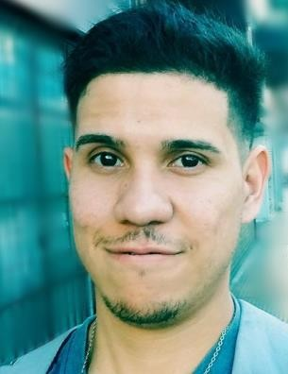

**IT**

SQL / PLSQL  HTML  CSS

PHP

JavaScript Git / GitHub

POO  JAVA  WINDOWS 

.NET

# S K I L L S

* + Teamwork
  + Commitment
  + Resilience
  + Proactivity

## E D U C A C I Ó N

En curso **Information System Engineering**

CABA *UTN- FRBA*

*“Im doing 3ero/4to level subjects”*

2010 **Electronics oriented technician**

BS AS *EET N°3*

## CURSOS

11/20 **Git y Github profesional**

Bs As *Platzi*

11/20 **Object Oriented Programing(OOP)**

Bs As *Platzi*

11/20 **Web Develpoment**

Bs As *Platzi*

11/20 **Good practices in writing code**

Bs As *Platzi*

04/21 **JavaScript fundamentals**

Bs As *Platzi*

## PERSONAL REFERENCES

* Lautaro Schein – General Manager at Garbarino S.A. suc Unicenter Tel.: 1165144360